Software Requirement Specification
The production of the requirements stage of the software development process is Software Requirements Specifications (SRS) (also called a requirements document). This report lays a foundation for software engineering activities and is constructing when entire requirements are elicited and analyzed. SRS is a formal report, which acts as a representation of software that enables the customers to review whether it (SRS) is according to their requirements. Also, it comprises user requirements for a system as well as detailed specifications of the system requirements.
The SRS is a specification for a specific software product, program, or set of applications that perform particular functions in a specific environment. It serves several goals depending on who is writing it. First, the SRS could be written by the client of a system. Second, the SRS could be written by a developer of the system. The two methods create entirely various situations and establish different purposes for the document altogether. The first case, SRS, is used to define the needs and expectation of the users. The second case, SRS, is written for various purposes and serves as a contract document between customer and developer.

Characteristics of good SRS

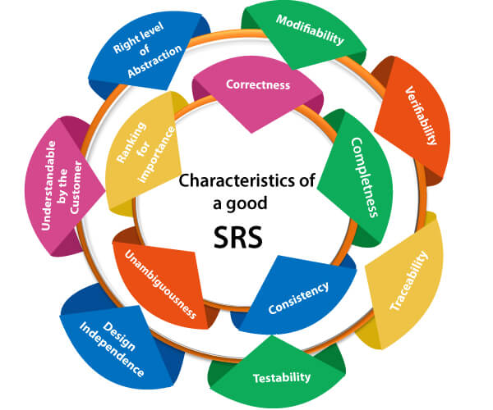

Following are the features of a good SRS document:
1. Correctness: User review is used to provide the accuracy of requirements stated in the SRS. SRS is said to be perfect if it covers all the needs that are truly expected from the system.
2. Completeness: The SRS is complete if, and only if, it includes the following elements:
(a). All essential requirements, whether relating to functionality, performance, design, constraints, attributes, or external interfaces.
(b). Definition of their responses of the software to all realizable classes of input data in all available categories of situations.
(c). Full labels and references to all figures, tables, and diagrams in the SRS and definitions of all terms and units of measure.
3. Consistency: The SRS is consistent if, and only if, no subset of individual requirements described in its conflict. There are three types of possible conflict in the SRS:
(a). The specified characteristics of real-world objects may conflicts. For example,
(i) The format of an output report may be described in one requirement as tabular but in another as textual.
(ii) One condition may state that all lights shall be green while another states that all lights shall be blue.
(b). There may be a reasonable or temporal conflict between the two specified actions. For example,
(i) One requirement may determine that the program will add two inputs, and another may determine that the program will multiply them.
(ii) One condition may state that "A" must always follow "B," while other requires that "A and B" co-occurs.
(c). Two or more requirements may define the same real-world object but use different terms for that object. For example, a program's request for user input may be called a "prompt" in one requirement's and a "cue" in another. The use of standard terminology and descriptions promotes consistency.

4. Unambiguousness: SRS is unambiguous when every fixed requirement has only one interpretation. This suggests that each element is uniquely interpreted. In case there is a method used with multiple definitions, the requirements report should determine the implications in the SRS so that it is clear and simple to understand.
5. Ranking for importance and stability: The SRS is ranked for importance and stability if each requirement in it has an identifier to indicate either the significance or stability of that particular requirement.
Typically, all requirements are not equally important. Some prerequisites may be essential, especially for life-critical applications, while others may be desirable. Each element should be identified to make these differences clear and explicit. Another way to rank requirements is to distinguish classes of items as essential, conditional, and optional.
6. Modifiability: SRS should be made as modifiable as likely and should be capable of quickly obtain changes to the system to some extent. Modifications should be perfectly indexed and cross-referenced.
7. Verifiability: SRS is correct when the specified requirements can be verified with a cost-effective system to check whether the final software meets those requirements. The requirements are verified with the help of reviews.
8. Traceability: The SRS is traceable if the origin of each of the requirements is clear and if it facilitates the referencing of each condition in future development or enhancement documentation.
There are two types of Traceability:
a. Backward Traceability: This depends upon each requirement explicitly referencing its source in earlier documents.
b. Forward Traceability: This depends upon each element in the SRS having a unique name or reference number.
The forward traceability of the SRS is especially crucial when the software product enters the operation and maintenance phase. As code and design document is modified, it is necessary to be able to ascertain the complete set of requirements that may be concerned by those modifications.
9. Design Independence: There should be an option to select from multiple design alternatives for the final system. More specifically, the SRS should not contain any implementation details.
10. Testability: An SRS should be written in such a method that it is simple to generate test cases and test plans from the report.

